Chapter 3
RESEARCH METHODOLOGY

This chapter discusses the methodology used to develop IronGrind: A Web-Based Fitness Gym Membership and Operations Management System for Iron Grind Fitness Gym in Purok Mangga, Sulangon, Dapitan City, Zamboanga del Norte. It describes the development process, system requirements, design, data organization, and evaluation procedures. The system is intended to organize membership applications and records, membership periods and renewals, staff-recorded attendance, products, sales, and reports. Its development is organized using Agile, with work planned and delivered incrementally. Proposed evaluation activities are distinguished from results that have not yet been collected.

System Development Methodology

Figure 1. Agile

Agile is an iterative system-development approach in which requirements guide the work, features are built in manageable increments, and the results of testing and review guide subsequent work. As shown in Figure 1, the process begins by planning IronGrind's workflows and priorities and designing the related pages, forms, data relationships, and access permissions. The team then develops a selected group of features and tests them against their requirements. Deployment in the cycle means preparing and checking an increment in its intended environment; review considers the test findings and any feedback actually collected. Those findings return to planning and help determine what to refine or build next. This cycle applies to the system's membership applications and renewals, attendance, inventory, sales, and reports. The final Launch stage represents release of the approved system for operational use after the required increments have been verified. Figure 1 describes this project's workflow; it does not claim use of a specific Agile framework or a fixed iteration length. Evaluation results are reported only after the planned evaluation activities have been completed.

Requirements Planning
Requirements planning identifies separate workflows for applicants, members, administrators, and authorized staff. Requirements cover online applications subject to administrator review, direct counter registration and membership changes, QR attendance, product inventory, transaction recording, reporting, staff accounts, phone pairing, and activity logs. Acceptance criteria include role permissions, required inputs, stock and membership updates, and rejection of unauthorized operations. These criteria guide each development increment.

User Design
Using the prioritized requirements, the team designs or refines the corresponding user workflows, page layouts, forms, reports, data relationships, and role permissions. For example, the design distinguishes pending applications from approved member records, keeps attendance as a separate operational record, and stores sales with their itemized lines. The architecture, use-case, and data-flow figures in this chapter summarize how these parts fit together. These designs are then represented in prototypes so that the intended workflows can be reviewed before or during construction.

Prototype
The prototype represents the designed workflows through browser-based pages. Applicants submit registration details, while members view their membership, attendance, QR code, profile, catalog, and renewal requests. Administrators review online requests and manage membership records, inventory, sales, staff access, phone pairing, activity logs, and reports. Staff use a separate portal for attendance, walk-in registration, direct membership renewals and active-member plan changes, product sales, and their own product-sale records. The system records in-person transactions without providing receipts to customers. Supabase Auth, database policies, functions, and authorized Edge Functions support the implemented operations.

Construction
The team constructs the selected increment using the HTML, CSS, and JavaScript client and Supabase authentication and PostgreSQL services. Database policies and functions support authorization and operational transactions. The completed increment is tested against the acceptance criteria established during planning. If a test identifies an issue, the team corrects it and checks it again; unresolved or newly discovered needs are recorded for prioritization. Once the increment passes the required checks, it can be prepared in the intended environment and reviewed. Test findings and any feedback actually collected inform the next planning cycle, connecting construction to continued refinement.

Implementation
Implementation prepares the verified increments for operational use. The team configures the website and Supabase project for the intended environment, applies the approved access policies, and prepares administrator access. Deployment refers to this environment preparation and release check; Launch is the point at which the approved system is made available for the gym's intended workflows. Staff orientation supports the transition to use. These activities follow testing and review, and their outcomes are reported only after they have actually been completed.

Requirement Specifications
This section outlines all the requirements needed for the IronGrind System. These requirements serve as the foundation for the system's design and validation. The requirements are divided into several categories: functional requirements, input requirements, output requirements, software requirements, and hardware requirements. Each category plays an important role in making sure the system is complete, efficient, and meets the needs of its users.

Functionality Requirements
Functional requirements distinguish applicants and members from administrators and authorized staff. Online registration and renewal requests are reviewed by administrators. Staff have assigned counter and attendance operations, while stock maintenance, staff account controls, phone pairing administration, activity-log review, and reports remain administrator functions.

Table 1. Functional Requirements
This section describes the main operations such as managing memberships, processing applications, recording attendance via QR, managing inventory, and generating reports. These functions ensure accurate record-keeping, efficient administration, and secure system operation.
Functional Requirements | Description
User Login | Authenticate administrators, staff, and members and enforce role-based access.
Membership Applications | Applicants submit registration requests; administrators review and approve or reject them.
User Management | Administrators manage users and staff-account access. Members view/update only their own permitted profile. Staff register walk-ins and process direct renewals or active-plan changes using limited lookup details; they cannot view or edit member profiles.
Renewals | Members request renewal; administrators review online requests. Direct staff counter renewals are covered under User Management.
QR Attendance | Authorized operators record QR check-in/out and read permitted visits; members read only their own history. Administrators manage phone pairing and its settings.
Products & Inventory | Administrators maintain products, prices, units, stock and active state. Members browse active products; staff read the sales catalog without inventory-maintenance access.
Sales | Authorized operators record in-person product sales and stock deductions. Staff review only their own product sales. Transactions are recorded without providing receipts.
Generate Reports | Administrators generate membership, attendance, inventory, sales and renewal reports with supported preview and export options.
Activity Logs | Administrators review recorded actions, including staff-account changes and phone-pairing events. This read-only function does not perform the logged operations.

Table 2. Input Requirements
Input requirements are the essential data and information that the IronGrind system needs to function properly. By ensuring that all required inputs are complete and accurate, the system can deliver reliable outputs and support effective decision-making.
Input Requirements | Description
User Login | Credentials and session details.
Membership Applications | Registration and health details from applicants; administrator review decisions.
User Management | Administrator user/account changes; member own-profile queries or permitted edits; staff walk-in details, limited searches, direct renewal or active-plan selections.
Renewals | Member renewal request and administrator review decision.
QR Attendance | Operator member QR and attendance query; member own-history query; administrator pairing setup, settings or removal request.
Products & Inventory | Administrator product/stock inputs; member active-catalog query; staff sales-catalog query.
Sales | Customer name, product, quantity, unit and payment details; permitted transaction query.
Generate Reports | Administrator report type and reporting period.
Activity Logs | Administrator filters for date, account name, action and area, plus pagination requests.

Table 3. Output Requirements
These are the main results or information that the system produces after processing the input data:
Output Requirements | Description
User Login | Authentication result and permitted dashboard.
Membership Applications | Own application status and administrator pending/reviewed application records.
User Management | Role-permitted user records and confirmations. Member: own profile. Staff: limited counter lookup and operation result only. Administrator: user/staff access state.
Renewals | Request status and updated membership dates following approval.
QR Attendance | Attendance confirmation/history appropriate to the role; administrator pairing states and settings.
Products & Inventory | Active/permitted catalog; administrator stock levels, product state and alerts.
Sales | Saved transaction and stock deduction; staff own product-sale records. No issued receipt.
Generate Reports | Report preview, print layout, PDF output or combined ZIP export.
Activity Logs | Filtered recorded activity showing time, actor, action, area and changed-field information.

Table 4. Software Requirements
The following software components are essential for both the development and deployment of the IronGrind System. These tools ensure that the system operates smoothly, meets all technical requirements, and delivers the necessary functionality.
Development | Description
Visual Studio Code | For coding and development.
HTML, CSS, JavaScript | For frontend design and user interface.
Supabase /PostgreSQL | For backend services, authentication, and PostgreSQL database management.
PgAdmin | Used to inspect and manage the Postgre SQL database and execute queries during development.
Git / GitHub | For version control and code repository.
Google Chrome or Microsoft Edge | For accessing and testing the system interface.

Table 5. Hardware Requirements
The hardware requirements describe practical development and operating equipment rather than benchmarked minimum performance. A browser-capable computer and stable internet connection support the main system; a supported camera-enabled phone or computer supports QR attendance. Printing is optional for operational reports. A dedicated POS terminal or receipt printer is not required.
Component | Minimum Specification | Recommended Specification | Description
Storage Drive | HDD 500 GB | SSD 500 GB or higher | The system is web-based, but an SSD improves local development and browsing speed.
Memory (RAM) | 8GB | 16GB or higher | Works with 8 GB RAM, but 16 GB+ is faster and more stable, especially for multitasking.
Processor (CPU) | Intel Core i3 | Intel Core i5 or higher | Both processors can run the system, but i5 delivers faster processing.
Laptop | Basic Laptop (Intel Core i3, 8GB RAM) | Mid-range Laptop (Intel Core i5, 16GB RAM) | Used by the gym owner/admin for managing the dashboard, applications, inventory, and generating reports.
Front-desk Device | Browser-capable computer | Computer with supported camera | Used for membership, attendance, and transaction recording; dedicated POS hardware is not required.
Printer | Optional | Available office printer | Optional printing of operational reports; receipt printing is not a requirement.
Operating System | Windows 10 (64-bit) | Windows 11 (64-bit) | Both operating systems are compatible with modern web browsers and POS software.
Camera/Scanner | Supported camera-enabled device | Clear-focus phone camera or webcam | Camera permission and a secure browser context support QR scanning. Paired phone use remains subject to operator authorization.
Internet Connection | 5 Mbps | 20 Mbps or higher | Since the system uses Supabase (cloud), a stable internet connection is required for real-time data syncing.

Data Process Modeling
The Data Process Modelling illustrates how data flows within the IronGrind System. It describes how information is gathered, processed, stored, and retrieved by the system. This model helps visualize the relationship between the users, the system processes, and the data stored in the system's Supabase PostgreSQL database.

Diagrams
In this study, diagrams serve as visual representations that illustrate how data and processes flow within the Iron Grind Fitness Gym Membership & Operations Management System. Each diagram shows how information is entered, processed, stored, and produced as system output. The visual format clarifies the structure, functions, and interactions among the users, system processes, and database. By presenting the system in a clear and organized graphical layout, each diagram simplifies complex workflows and supports easier analysis and understanding. Every illustration also provides an overview of how all modules operate together to achieve efficient gym management.
In addition, each diagram contributes to identifying potential areas for improvement by highlighting connections, dependencies, and overall workflow behavior. The graphical representation helps developers and stakeholders visualize how every process supports the system's intended functions. Accurate documentation is also supported, ensuring proper interpretation during development, refinement, and evaluation. Overall, each diagram plays crucial role in communicating the system's design, logic, and expected performance in a structured and easy-to-interpret format.
Figure 2 is the context diagram. It contains one process, numbered 0, representing IronGrind and three external actor groups: Member / Applicant, Administrator, and Authorized Staff. Databases, authentication services, and phone-pairing storage remain internal to the system boundary.
- The Member/Applicant provides inputs such as sign-in credentials, registration details, membership applications, renewal requests, and profile updates. In return, the system provides outputs including authentication results, application statuses, membership details, attendance history, the active product catalog, and account information.
- The Administrator provides application review decisions, membership and inventory updates, sales entries, staff account controls, phone-pairing administration, and report or activity-log queries.
The system returns the corresponding records, status confirmations, account information, activity logs, and reports. Authorized staff provide attendance scans, walk-in registration details, direct renewal and plan-change inputs, and product sales entries; they receive only the confirmations and records permitted for their role.

Context Diagram
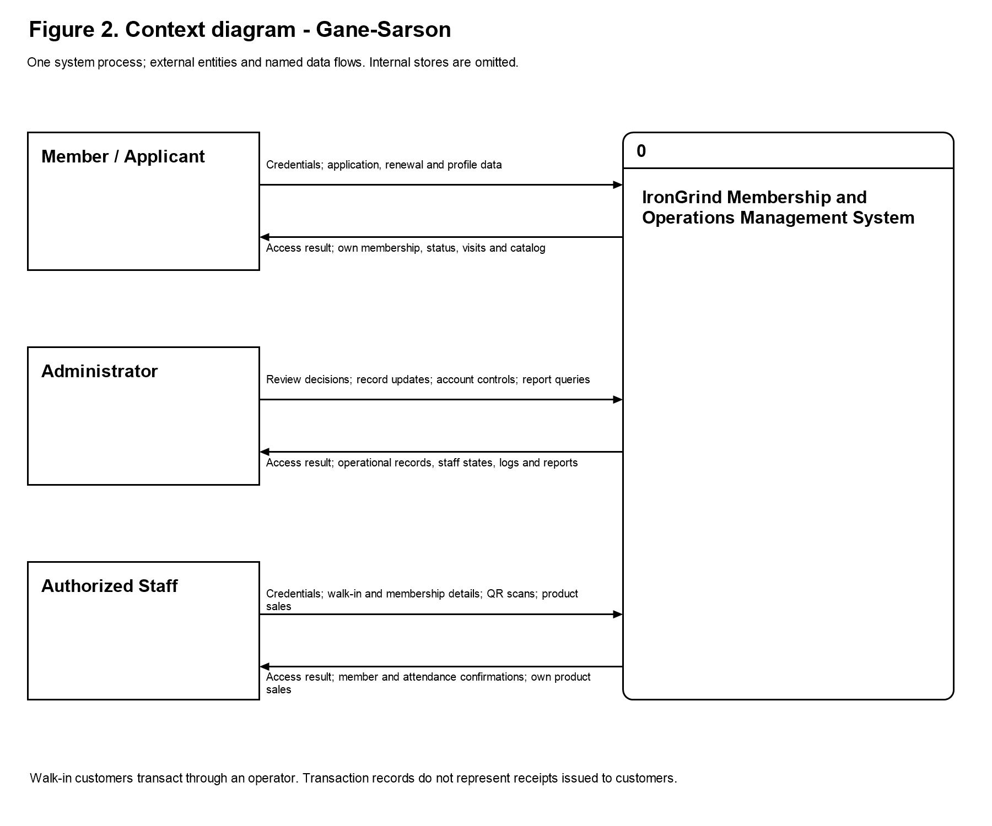
Figure 2. Context - Gane-Sarson
Figure 2 shows the exchange of data between the three actor groups and the whole system. Unlike the Level 1 DFD, the context diagram does not expose internal processes or data stores. Walk-in customers transact through an administrator or staff operator and do not access a member account solely to make a product purchase.
The Member / Applicant submits credentials, registration details, renewal requests, and profile changes and receives their own application status, membership information, attendance history, QR code, and active catalog. Administrator and staff inputs differ according to their assigned permissions. Transaction confirmations refer to saved system records; they do not represent receipts issued to customers.

Data Flow Diagram
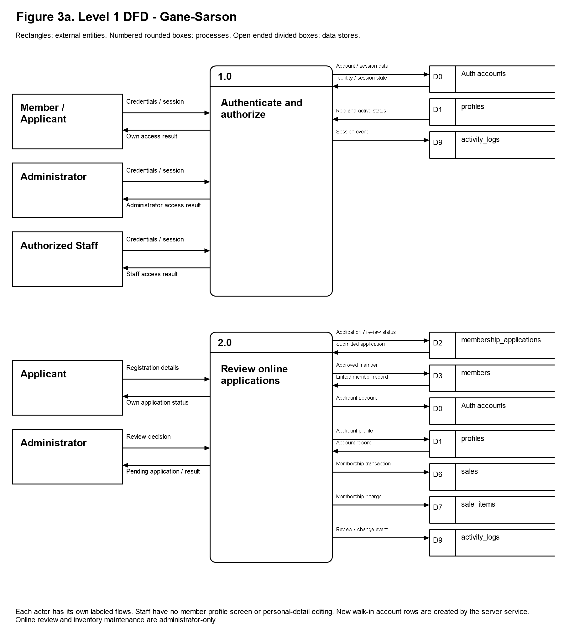
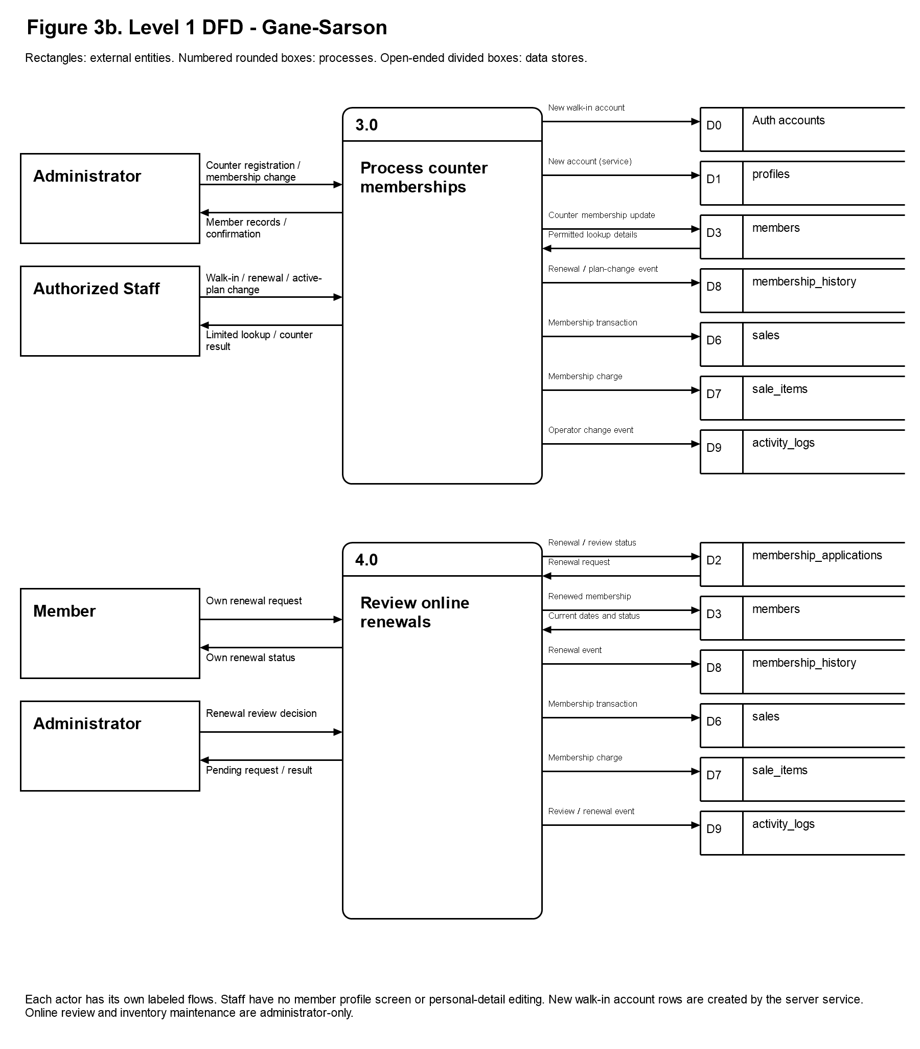
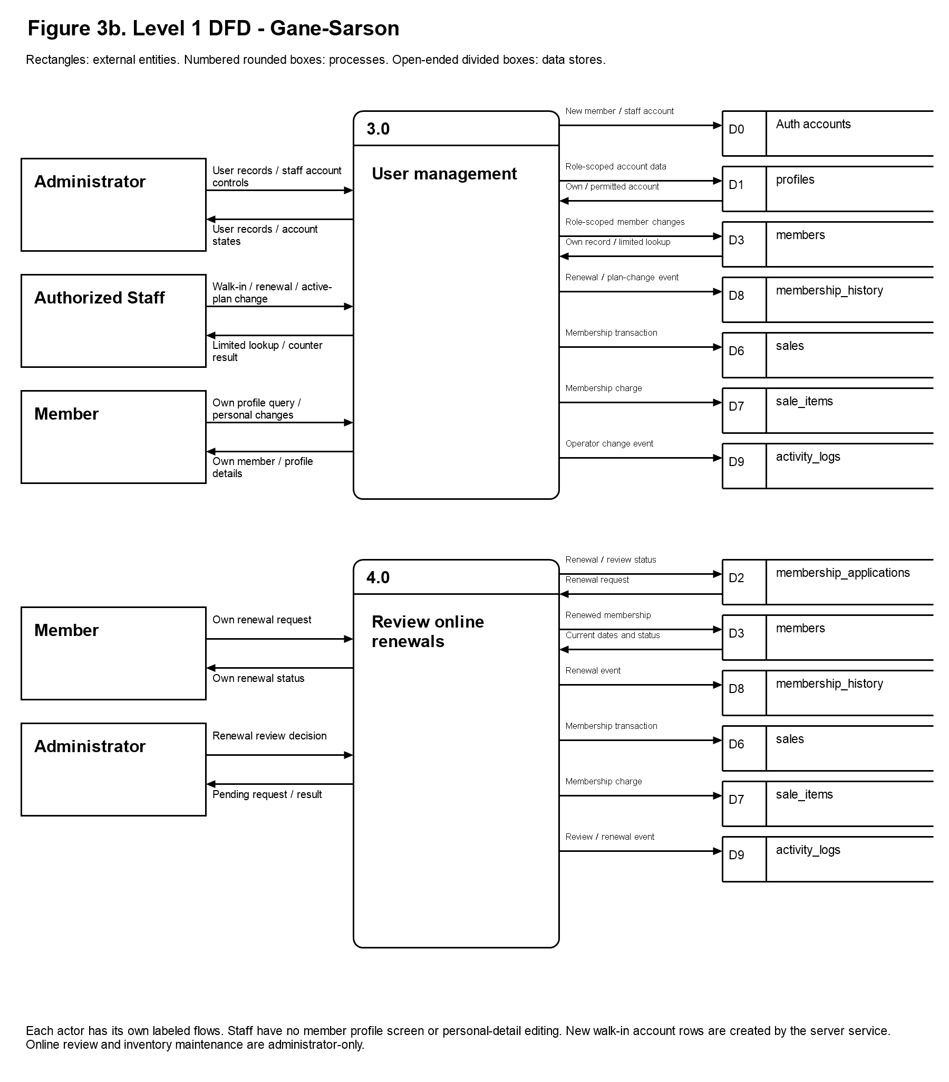
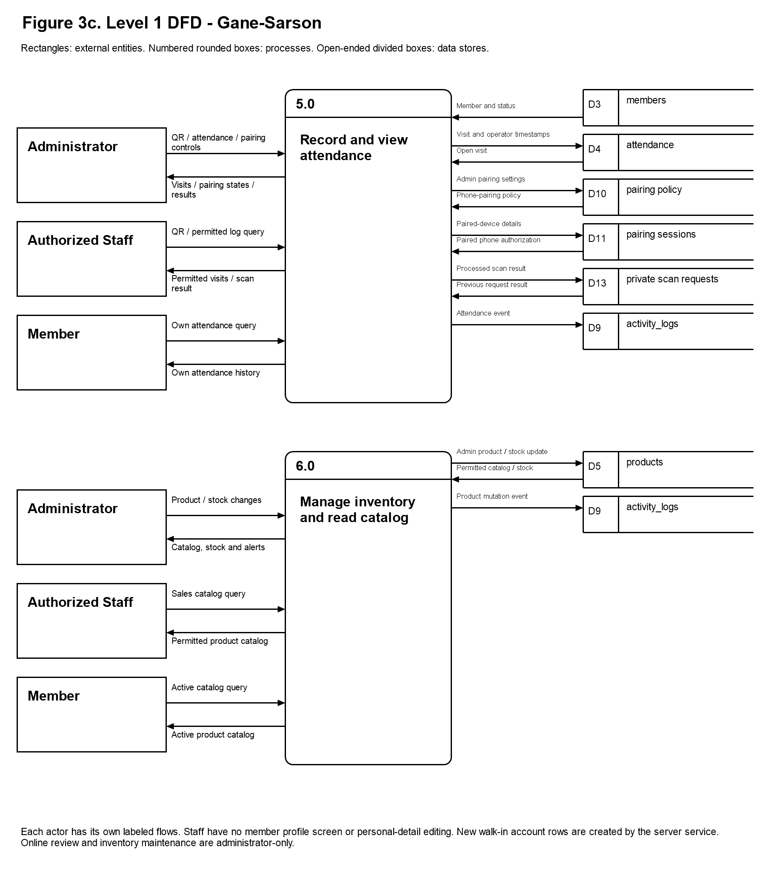
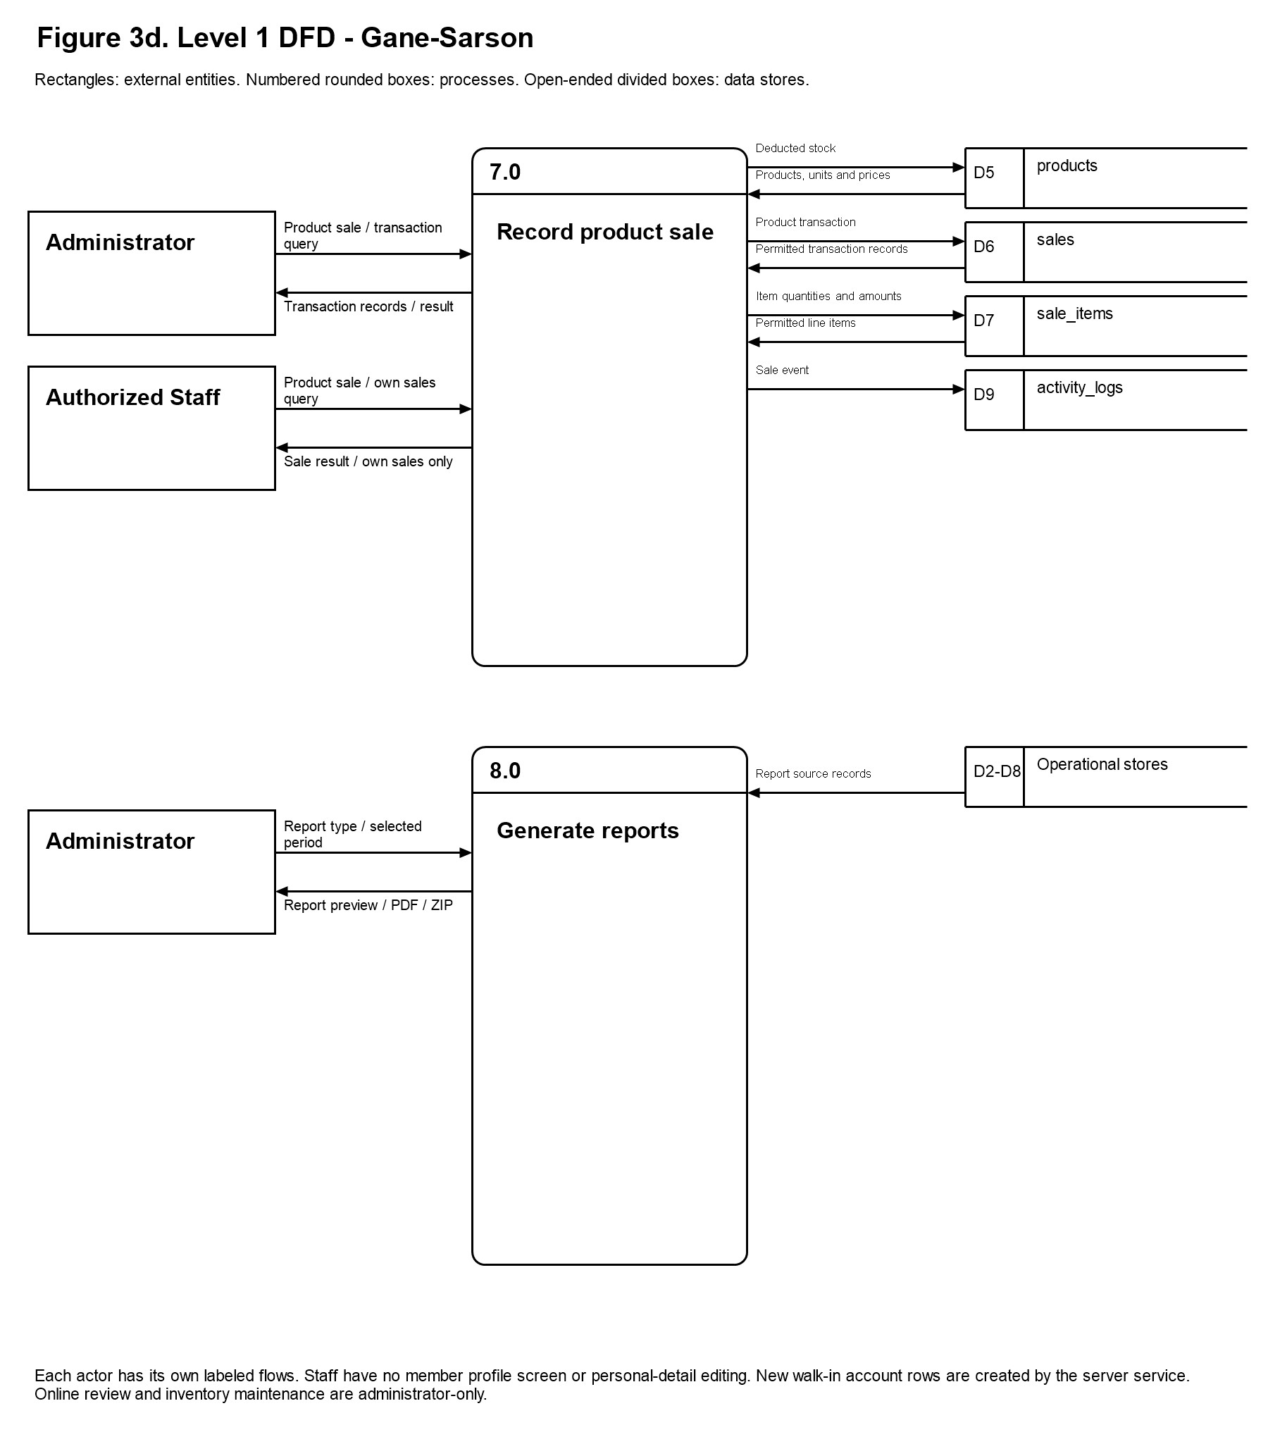
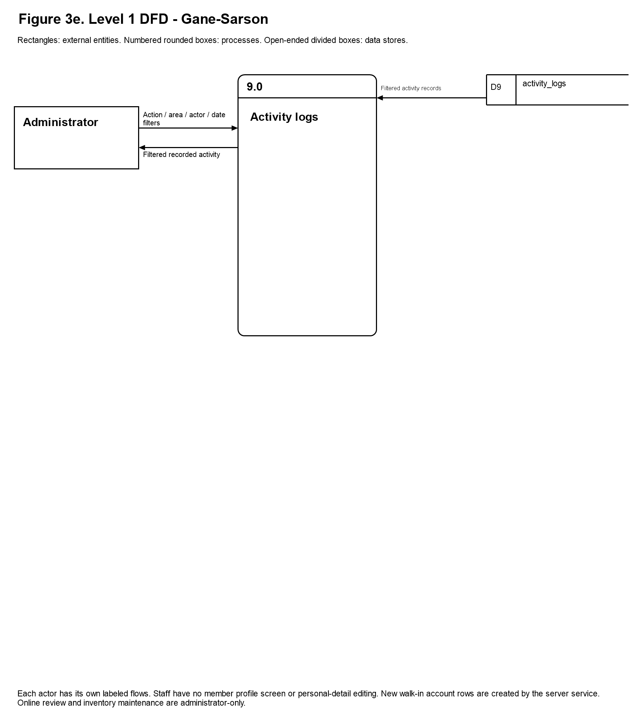
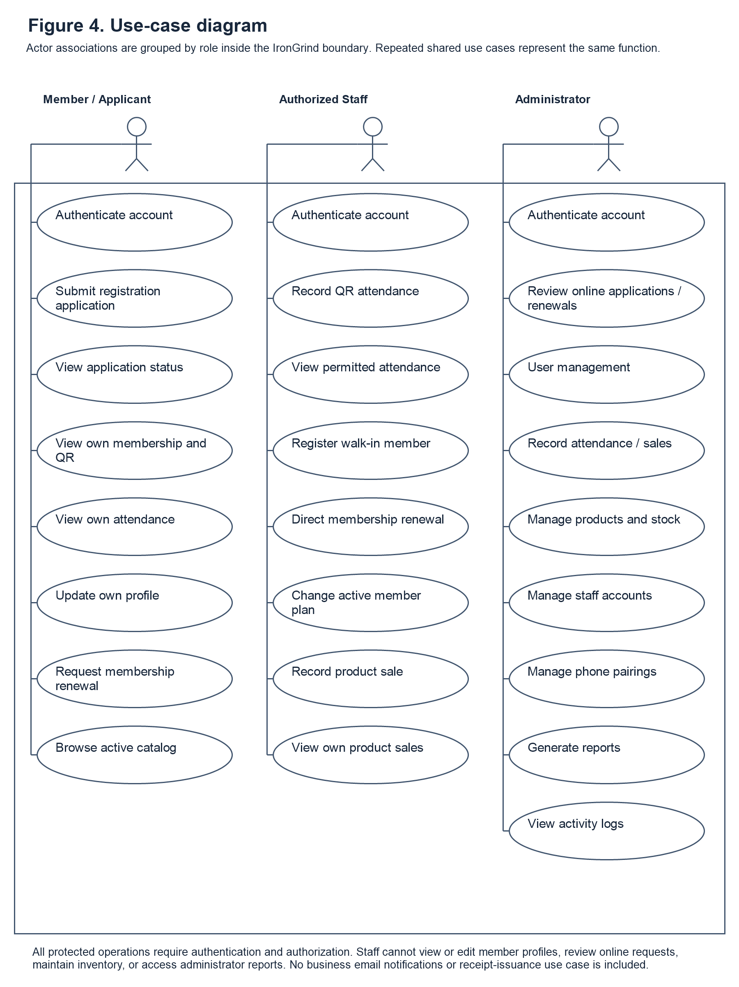
Figure 3a-e. Level 1 Data Flow - Gane-Sarson
Figure 3a-e uses Gane-Sarson notation to decompose the system into nine processes across five continuation panels. Numbered, divided rounded boxes represent processes; rectangles represent external entities; and open-ended boxes with a separate identifier compartment represent data stores. Labeled arrows name the exchanged data. Repeated actor and store references describe the same logical actors and data stores in separate lanes. D1 is profiles; D2, membership_applications; D3, members; D4, attendance; D5, products; D6, sales; D7, sale_items; D8, membership_history; and D9, activity_logs. D10 represents phone-pairing policy; D11, phone-pairing sessions; D12 is reserved for the retained scan-event table (not an active interface flow); and D13, private attendance scan requests. D0 represents the managed Auth account store. D2-D8 in process 8.0 groups operational report sources. Process 9.0 reads D9 activity_logs only. User Management includes member self-service and administrator staff-account controls; each role has its own labeled arrows. D12 is a retained scan-event table in the physical schema, not an active interface flow. Supabase Auth manages credentials separately from D1. Operational mutations and logging functions also create activity records. Supporting private scan-request storage prevents duplicate scan processing.

- 1.0 Authenticate and Authorize
Supabase Auth verifies credentials and establishes the user session. The system reads the profile role and active-account state to route the account to the administrator, staff, or member interface. Authorization is enforced through database policies, role-checked functions, and Edge Functions, rather than relying on page visibility alone.
2.0 Review Online Applications. Applicants submit registration details and health declarations to membership_applications. Only administrators review online requests and approve or reject them. Approval creates or links the member record, updates the application status, and records the applicable membership payment through sales and sale_items. Direct walk-in registration follows process 3.0 instead of granting staff online-review permission.
3.0 User Management. Administrators manage user/member records and create or activate/deactivate staff accounts through authorized services. Members can retrieve and update only their own permitted personal details. Staff have a separate labeled counter flow: walk-in registration, limited member lookup, direct renewal, and active-member plan change. Staff cannot view or edit existing member profiles. Account rows created by the registration service describe backend storage, not profile-editing permission granted to staff. Membership changes record applicable member, history, sales, and sale-item updates.
4.0 Review Online Renewals. Members submit renewal requests to membership_applications. Administrators approve or reject these requests. An approved renewal preserves unused time by extending an active membership from its current expiry date; an expired membership restarts on approval. Approval updates the member, history, application status, and membership transaction records. Direct counter renewals by an administrator or staff operator belong to process 3.0 and do not grant staff permission to review online requests.
5.0 Record and View Attendance. An authorized administrator or staff operator scans a member QR code with a supported computer or phone camera. The database validates the operator and member, checks for an open visit, and records check-in or check-out in attendance. recorded_by and checked_out_by identify the operators for each event. Private attendance_scan_requests records support duplicate-request protection. Paired phones additionally use administrator-managed pairing sessions and policy; pairing does not replace operator authentication. Members can read their own attendance history. Authorized staff and administrators read attendance within their permitted scope. Administrator-only phone-pairing creation, settings and removal belong to this attendance workflow. Staff and members do not receive those administration controls.
6.0 Manage Inventory and Catalog. Administrators maintain product details, prices, stock, product forms, and active or archived state. Powder supplements support weight units; drinkable supplements support volume units; capsules and tablets use pieces or boxes; other supplements and merchandise use items. Sale processing converts compatible quantities and deducts stock using the configured inventory units. Members browse active products, and staff obtain the permitted catalog needed for sales; these read operations do not grant inventory-maintenance permission.
7.0 Sales
Administrators and staff record in-person product purchases for members or walk-in customers. The sale operation validates quantities and product status, writes sales and sale_items, and deducts product stock. Membership charges are recorded through the membership operations in processes 2.0 to 4.0. The database retains the existing receipt_number field as an internal transaction identifier. The documented operating process does not provide customers with receipts.
8.0 Generate Reports
Administrators select a report type and period to retrieve the relevant operational records. Supported outputs include preview, print layout, individual PDFs, and combined ZIP export. This reporting process does not manage staff access, phone pairings, or activity-log filters.
9.0 Activity Logs. Administrators review database-recorded actions using date, account, action, and area filters and pagination. Logs include recorded staff-account changes and phone-pairing events. The interface reads activity_logs; it does not create staff accounts, alter pairing settings, or modify the recorded events. Those operations occur in User Management or QR Attendance and produce their own log entries.

Use Case Diagram
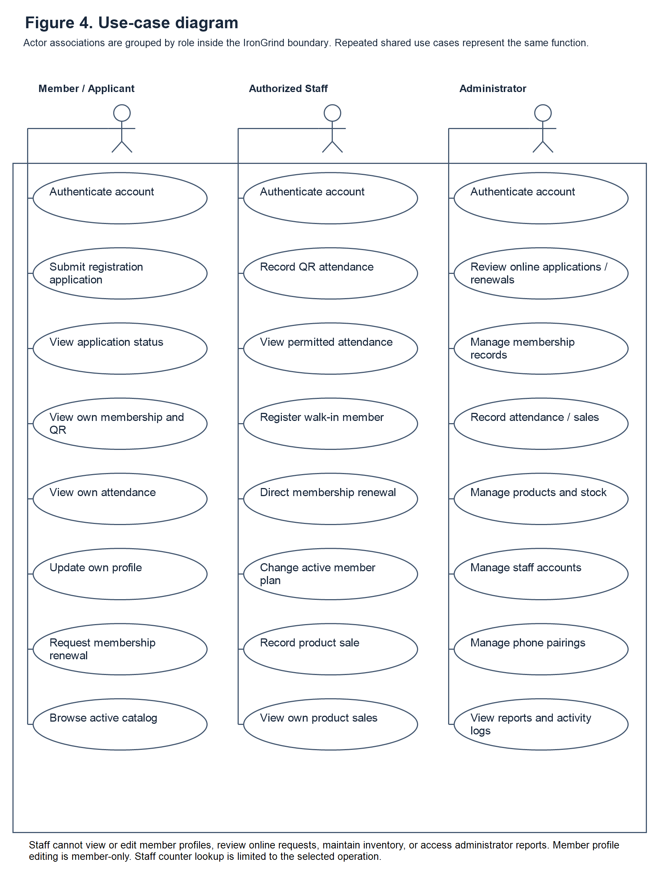
Figure 4. Use Case
Figure 4 distinguishes the Member / Applicant, Authorized Staff, and Administrator actors. Each column associates one actor with its available use cases inside the IronGrind system boundary. Repeated shared use cases, such as authentication and attendance recording, refer to the same system function.
These use cases outline the specific actions, such as managing membership information, updating records, and generating reports, that contribute to the system's overall functionality. The object model ensures that all necessary functions are clearly defined, organized, and accessible only to authorized users to maintain security and accuracy.
It also serves as a blueprint for system design, making it easier to implement, test, and maintain the system. By providing a structured representation, the model minimizes potential errors and ensures that all user requirements are addressed.
Administrator and staff permissions are shown separately. Staff have no member-profile viewing or personal-detail editing function and do not inherit administrator access to online application review, inventory maintenance, staff account controls, phone-pairing administration, reports, or activity logs.
The User is responsible for managing their personal profile, submitting membership applications and renewals, and viewing their attendance history.
Administrators review online applications and renewal requests and manage membership records, products, stock, staff access, phone pairings, activity logs, and reports. Staff record attendance, register walk-in members, perform permitted direct membership changes, record product sales, and review their own product-sale records.
Each of these processes represents a key function of the system, ensuring that gym information is accurately maintained, updated, and easily accessible. These tasks also demonstrate how the system supports efficient documentation, organized data management, and streamlined workflow for gym operations.

1. Authenticate Account
Supabase Auth verifies credentials. The profile role and active-account state determine administrator, staff, or member access, with protected operations checked by server-side authorization.
2. Register and Submit Membership Application
This function allows the User to create an account and submit their personal and health information, which is then sent to the Admin for review.
3. Review Membership Applications
The Admin can view the submitted applications and make a decision to either approve or reject them based on the gym's criteria.
4. Create or Link Member Account. Administrator approval links an online application to the approved member record. Direct walk-in registration by an authorized administrator or staff operator uses a server-side Edge Function to create the appropriate Auth, profile, member, and payment records.
5. View Application status at Login
The User can check the real-time status of their membership application upon logging in to see if it is pending, approved, or rejected.
6. View Membership Dashboard
This function allows the User to access their personalized dashboard, displaying their active membership plan, time-based progress, and their unique QR code.
7. User Management The Admin can view, update, search, and archive member profiles and membership histories to keep the database organized.
8. Record Membership Attendance. An administrator or authorized staff operator scans a member QR code using a supported computer or phone camera. The system records a check-in or check-out and the responsible operator.
9. View Personal Attendance History
The User can view a detailed log of their own gym visits, including the dates and exact times they entered and exited the gym.
10. Manage Profile
This function allows the User to update their personal information, contact details, and account settings securely.
11. Browse Active Product Catalog
The User can view the available supplements and merchandise sold by the gym.
12. Manage Products and Inventory
The Admin can add, update, and monitor the product catalog, ensuring that merchandise stock quantities and supplement details are accurate.
13. Record Product Sale. An administrator or staff operator records an in-person product purchase, with validated quantities, saved sales and line items, and corresponding stock deduction. Staff can review their own product-sale records. No receipt provision is included in the documented operating process.
14. Submit Membership Renewal Request
This function allows a member to submit a renewal request at any time, subject to administrator approval. If approved while the membership is active, the new membership duration is added after the current expiry date. If approved after expiration, the renewed period begins on the approval date.
15. View Dashboard and Operational Reports
The Admin can view a summarized dashboard showing active members, daily sales, and attendance, as well as access specific operational reports.
16. Export Reports
This function allows the Admin to generate, download, or print detailed reports for record-keeping and business analysis.
17. Activity Logs and Related Administration. The administrator reviews recorded activity through the Activity Logs use case. Staff-account changes are performed under User Management; phone-pairing changes are performed under QR Attendance administration. These operations generate log entries but are not performed inside the read-only log viewer. Business approval or expiry email notifications are not included as implemented use cases.

Entity Relationship Diagram
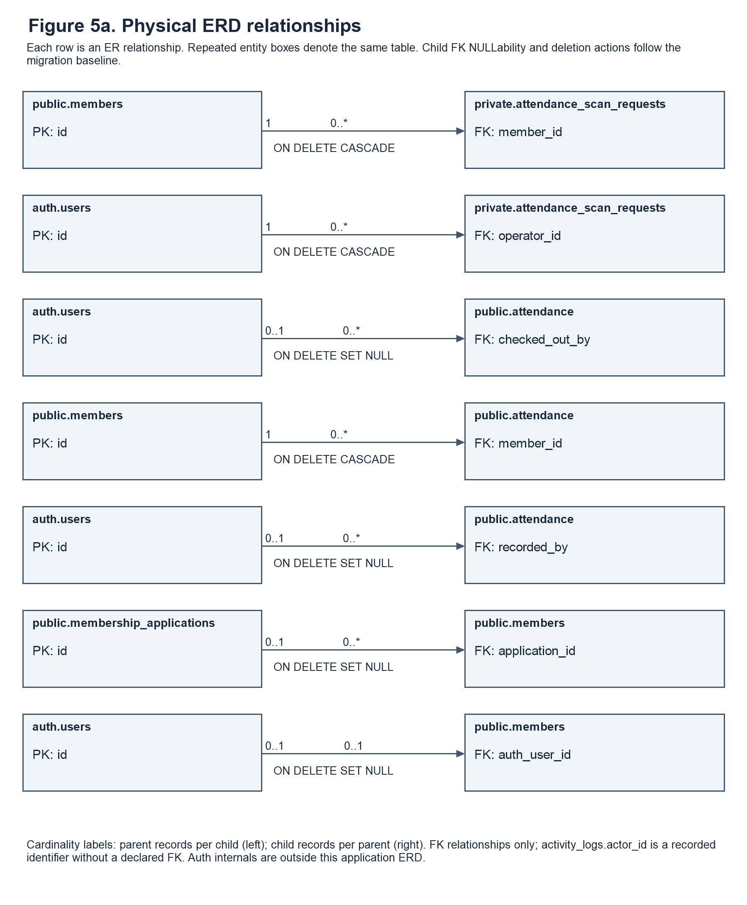

Entity Relationship Diagram
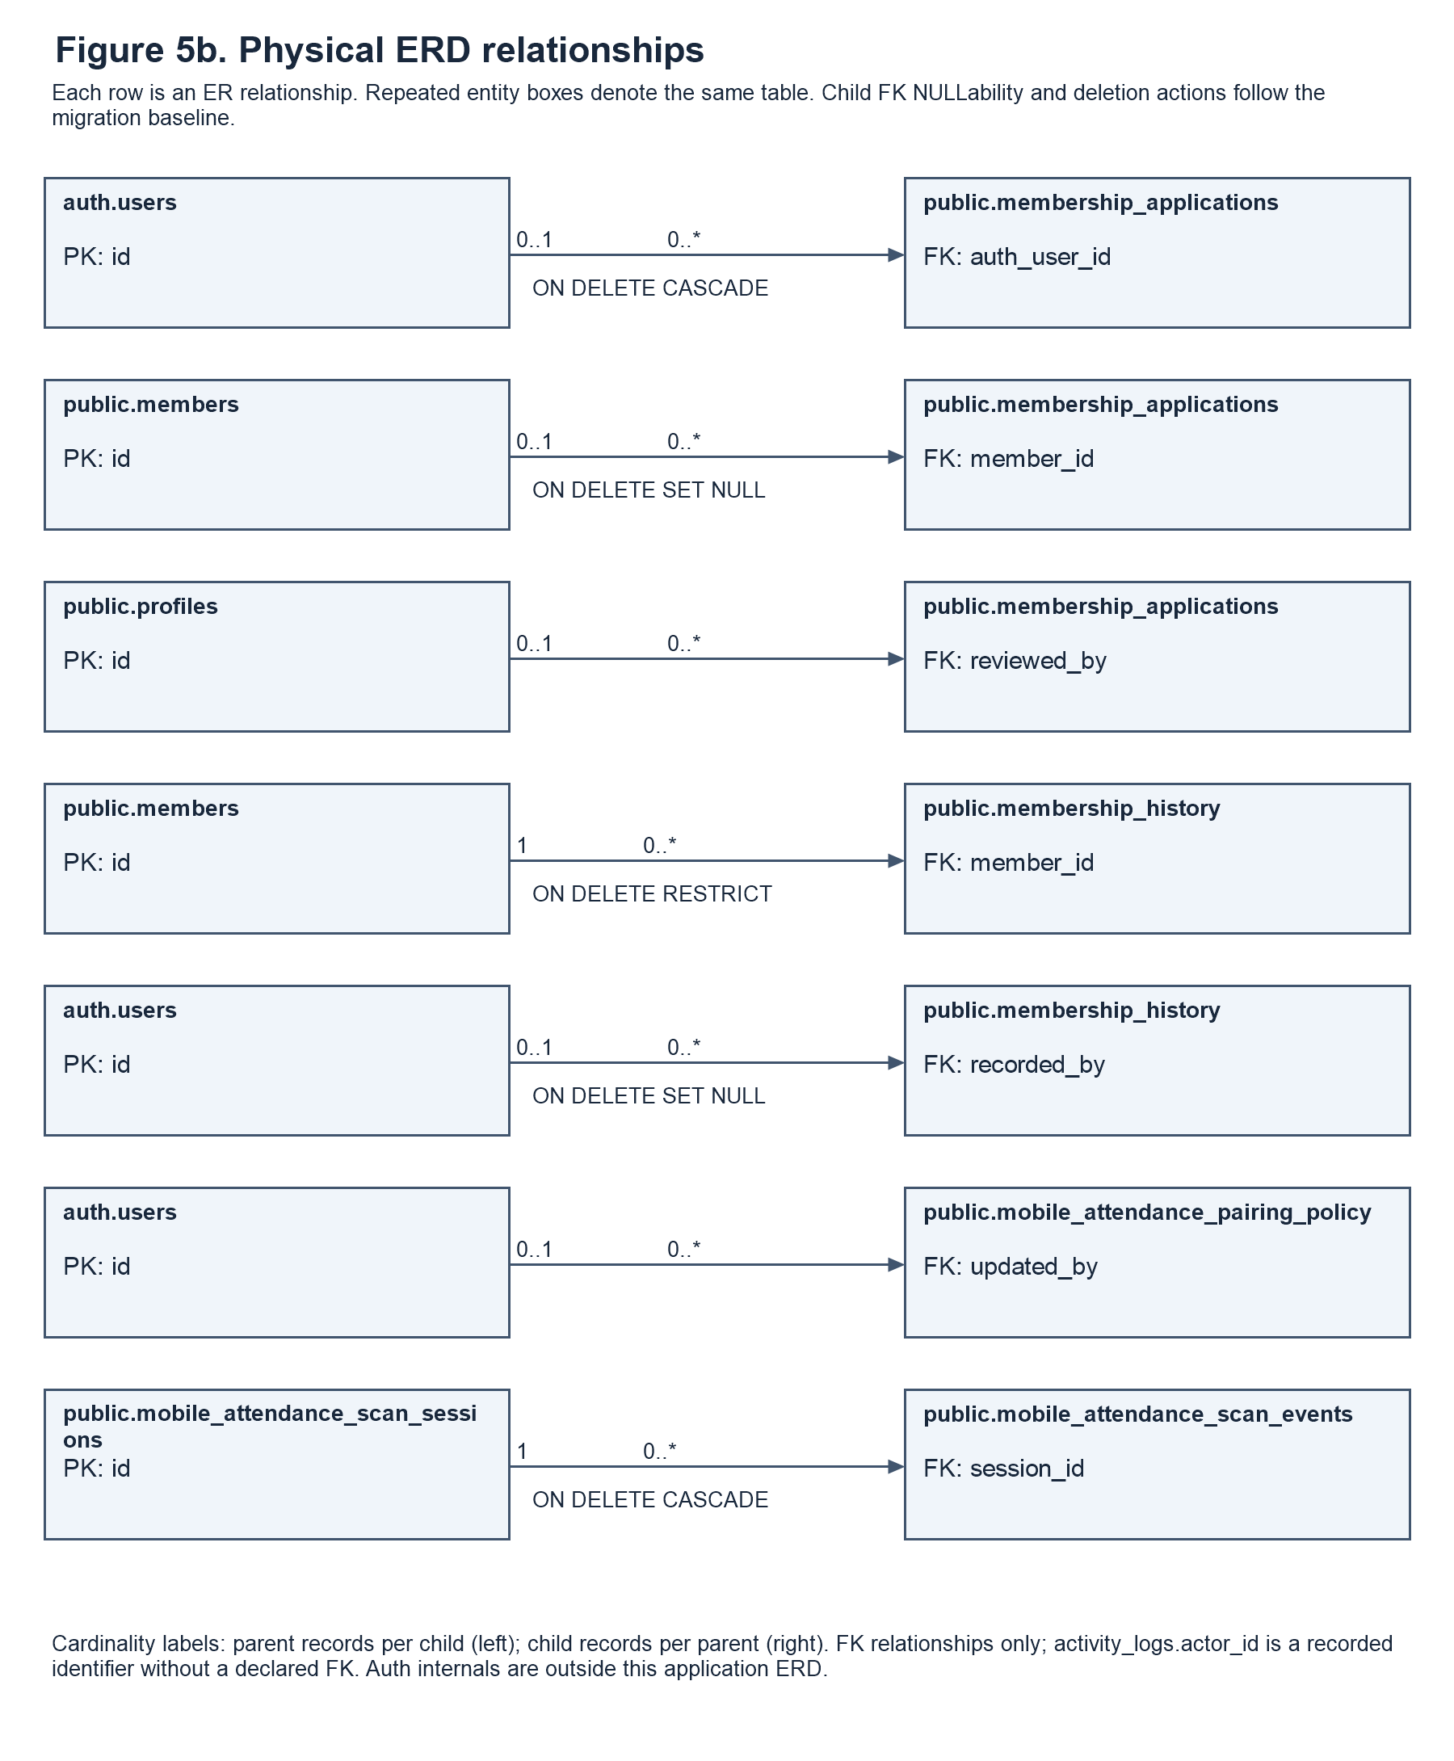

Entity Relationship Diagram
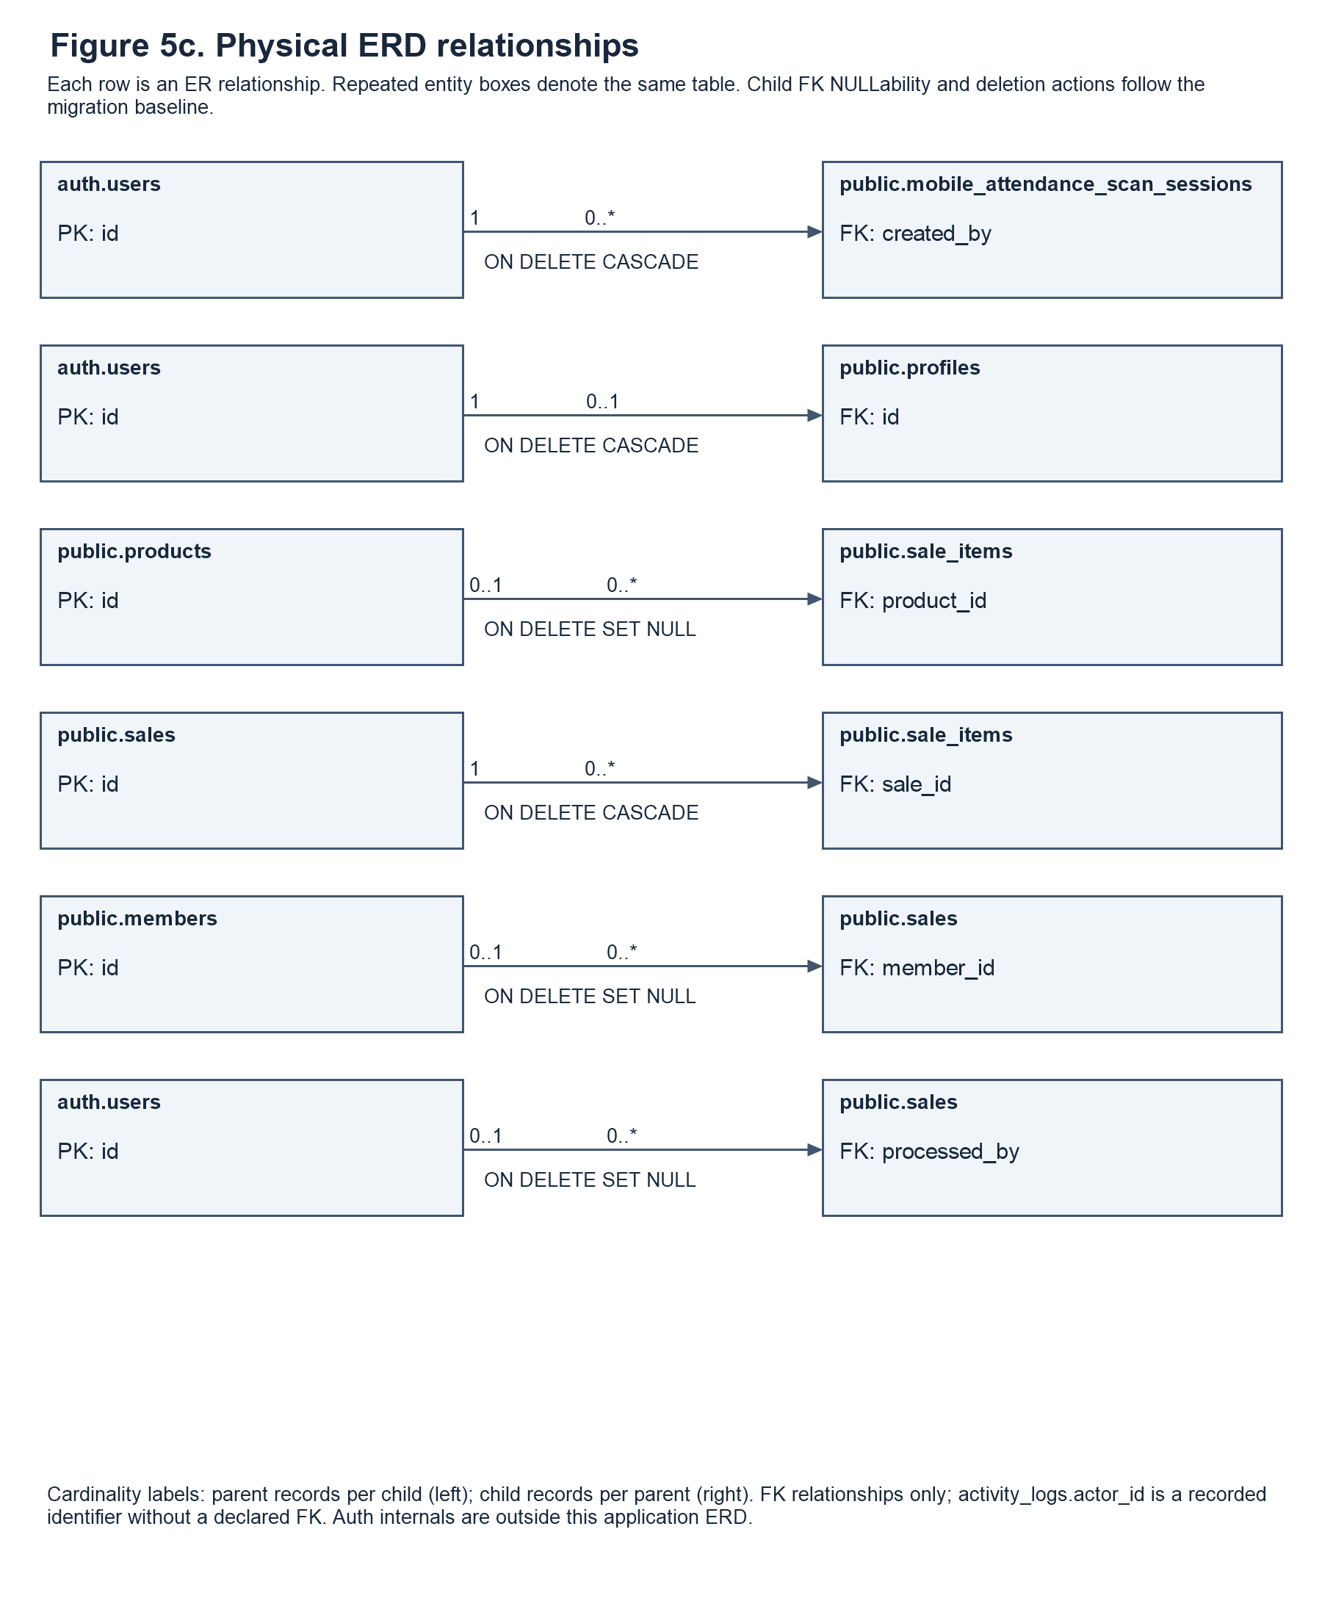
Figure 5a-c. Physical entity relationships
The physical ERD in Figure 5a-c follows declared foreign keys in the current database migration baseline. Each panel presents parent-to-child relationships, foreign-key fields, cardinalities, and deletion actions. Repeated boxes refer to the same table. The model includes application tables and supporting phone-pairing and private attendance-request tables. Managed Supabase Auth internals are outside the application schema shown here. The retained mobile_attendance_scan_events table belongs to the physical schema; the current frontend does not expose a separate scan-event review or clearing feature.

1. auth.users Entity
This entity serves as the primary authentication table for the system. It stores the unique identifier (id) and email address of every user. This entity is crucial for system security, ensuring that only individuals with verified credentials can log in and access the system.
2. profiles Entity. Each profile shares its primary key with auth.users and records the administrator, staff, or member role, account status, active flag, name, username, email, phone number, gender, and timestamps.
3. membership_applications Entity
This table stores data from new applicants and renewal requests awaiting admin review. It tracks the application type, selected plan, current status, and submission time. It links to the user applying (auth_user_id) and the admin who reviewed it (reviewed_by).
4. members Entity
The members table stores each member’s personal information, current membership plan, membership dates, status, and registration source. It links to the member’s Supabase Auth account and may reference a registration application. The application reference can be empty for members created directly by an administrator.
5. attendance Entity. Each visit references a member and stores its date and check-in and optional check-out timestamps. recorded_by and checked_out_by independently reference the Auth accounts responsible for the two attendance events.
6. products Entity. Products store category, price, stock, stock and sale units, supplement form and type, merchandise type, size, active or archived state, and image reference. Stock is numeric and supports product-appropriate weight, volume, piece, box, or item units.
7. sales Entity. Each row stores a transaction total, customer details, optional member reference, status, sold_at timestamp, and processing Auth account. The retained receipt_number column is an internal transaction reference; its technical name does not mean that a receipt is provided to the customer.
8. sale_items Entity. Each line belongs to one sale and optionally references a product. It preserves the item or membership label, category, quantity, unit, price, and line total. Membership charges have no product reference, and historical item labels remain available if a product reference becomes NULL.
9. membership_history Entity. History records reference a member and optionally the responsible Auth account. They retain renewal, plan-change, or expiry events and the membership values before and after the event.
Auth Users to Profiles and Members. An Auth account can have at most one profile and at most one linked member record. Each profile requires an Auth account; a member record can exist without an Auth link. Administrator, staff, and pending-applicant accounts need not have a linked member record.
Members to Membership Applications. This is a one-to-many relationship: a member can have multiple membership applications over time, including renewal requests. Each application may reference one member. A pending registration application can exist without a linked member record until it is processed.
Members to Attendance. This is a one-to-many relationship because a member can have multiple attendance logs (check-ins) over their membership period, but each attendance record is tied to only one member.
Members to Sales. This is a one-to-many relationship because a member can make multiple product purchases (sales), but each sale is tied to only one member (if it is not a walk-in).
Members to Membership History. This is a one-to-many relationship because a member can have multiple history records (renewals, plan changes) over time, but each history record is linked to only one member.
Sales to Sale_Items. This is a one-to-many relationship because a single sales transaction can contain multiple items (sale_items), but each sale_item belongs to only one sale.
Products to Sale_Items. A product can appear in multiple sale items. Each sale item may reference one product, while membership charges have no product reference. The item name and price are retained as transaction snapshots
Supporting Relationships. Online application reviewed_by references profiles, while attendance and transaction operator fields reference auth.users. Phone sessions reference their creator, scan events reference their session, and pairing policy optionally references its updating Auth user. Private attendance_scan_requests references an operator and member. activity_logs.actor_id is a stored actor identifier without a declared foreign key; it is not drawn as an enforced relationship.
Overall Description
The ERD includes core membership and transaction relationships and supporting identity and phone-attendance relationships. Nullable references permit walk-in sales without a member, membership charges without a product, and membership records without an Auth account. Referential actions follow the baseline: attendance.member_id cascades on member deletion, while membership_history.member_id restricts deletion. The dictionary below lists actual column types, NULLability, and declared keys from the same baseline rather than assuming that similarly named fields have identical types.

Data Dictionary
The data dictionary lists application and supporting database tables from the current checked-in migration baseline. Each entry identifies a column, its PostgreSQL type and size, declared key, and NULLability or purpose. Physical fields retained for compatibility are listed even when current forms prefer a newer field. Supabase Auth tables are managed by the authentication service and are not reproduced as an application-owned dictionary.
Each table in the database represents a specific entity within the system. The following are the detailed descriptions of all tables and their corresponding fields, providing clearer understanding and structure.

Table 6: profile
Stores account-facing profile details, administrator/staff/member roles, account status, active-account controls, contact details, and timestamps.
Field Name | Field Type | Length | Key | Description
id | uuid |  | PK, FK | Required. References auth.users.id.
username | character varying |  |  | Nullable.
full_name | character varying |  |  | Required.
role | character varying |  |  | Required.
account_status | text |  |  | Required.
created_at | timestamptz |  |  | Required.
updated_at | timestamptz |  |  | Required.
email | character varying |  |  | Nullable.
is_active | boolean |  |  | Required.
phone_number | text |  |  | Nullable.
gender | text |  |  | Nullable.

Table 7: members
Stores each gym member's current personal details and membership information. Previous membership changes are recorded separately in `membership_history`.
Field Name | Field Type | Length | Key | Description
id | uuid |  | PK | Required.
application_id | uuid |  | FK | Nullable. References public.membership_applications.id.
full_name | character varying |  |  | Required.
mobile | character varying |  |  | Nullable.
plan | character varying |  |  | Required.
start_date | date |  |  | Nullable.
end_date | date |  |  | Nullable.
status | character varying |  |  | Required.
paid | numeric |  |  | Required. Recorded membership payment amount; not a Boolean flag.
fitness_goals | text[] |  |  | Required.
height | numeric |  |  | Nullable.
height_unit | character varying |  |  | Nullable.
weight | numeric |  |  | Nullable. Compatibility weight measurement; weight_kg is also retained.
health_conditions | text[] |  |  | Required.
other_medical_conditions | text |  |  | Nullable.
signature_data | text |  |  | Nullable. Compatibility signature data field.
created_at | timestamptz |  |  | Required.
auth_user_id | uuid |  | FK | Nullable. References auth.users.id.
email | character varying |  |  | Nullable.
username | character varying |  |  | Nullable.
date_of_birth | date |  |  | Nullable.
age | smallint |  |  | Nullable.
sex | character varying |  |  | Nullable.
weight_kg | numeric |  |  | Nullable.
emergency_contact | jsonb |  |  | Required.
plan_price | numeric |  |  | Required.
expiry_date | date |  |  | Nullable.
registration_source | character varying |  |  | Required.
signature_path | text |  |  | Nullable.
updated_at | timestamptz |  |  | Required.

Table 8: membership_applications
Stores submitted registration and renewal requests with the information provided by the applicant. Review status, reviewer, and timestamps track each request through processing.
Field Name | Field Type | Length | Key | Description
id | uuid |  | PK | Required.
full_name | character varying |  |  | Required.
date_of_birth | date |  |  | Nullable.
age | integer |  |  | Nullable.
sex | character varying |  |  | Nullable.
mobile | character varying |  |  | Nullable.
height | numeric |  |  | Nullable.
height_unit | character varying |  |  | Nullable.
weight | numeric |  |  | Nullable. Compatibility weight measurement; weight_kg is also retained.
emergency_name | text |  |  | Nullable.
emergency_relationship | text |  |  | Nullable.
emergency_contact | text |  |  | Nullable.
plan | character varying |  |  | Required.
plan_price | numeric |  |  | Required.
start_date | date |  |  | Nullable.
end_date | date |  |  | Nullable.
health_conditions | text[] |  |  | Required.
other_medical_conditions | text |  |  | Nullable.
fitness_goals | text[] |  |  | Required.
signature_data | text |  |  | Nullable. Compatibility signature data field.
status | character varying |  |  | Required.
reviewed_by | uuid |  | FK | Nullable. References public.profiles.id.
reviewed_at | timestamptz |  |  | Nullable.
created_at | timestamptz |  |  | Required.
auth_user_id | uuid |  | FK | Nullable. References auth.users.id.
member_id | uuid |  | FK | Nullable. References public.members.id.
application_type | character varying |  |  | Required.
submitted_at | timestamptz |  |  | Required.
email | character varying |  |  | Nullable.
username | character varying |  |  | Nullable.
emergency_contact_data | jsonb |  |  | Required. Structured emergency-contact payload.
weight_kg | numeric |  |  | Nullable.
signature_path | text |  |  | Nullable.

Table 9: attendance
Stores one record for each member visit to the gym. Check-in and optional check-out timestamps support attendance history and visit tracking.
Field Name | Field Type | Length | Key | Description
id | uuid |  | PK | Required.
member_id | uuid |  | FK | Required. References public.members.id.
date | date |  |  | Required.
time_in | timestamptz |  |  | Required.
time_out | timestamptz |  |  | Nullable.
created_at | timestamptz |  |  | Required.
recorded_by | uuid |  | FK | Nullable. References auth.users.id. Auth account responsible for recording the event.
checked_out_by | uuid |  | FK | Nullable. References auth.users.id. Auth account responsible for check-out.

Table 10: products
Stores products offered for sale, including prices, units, and inventory information. Active and archived product records support catalog management and sales history.
Field Name | Field Type | Length | Key | Description
id | uuid |  | PK | Required.
name | character varying |  |  | Required.
category | character varying |  |  | Required.
price | numeric |  |  | Required.
stock | numeric |  |  | Required. Product quantity on hand in the configured stock unit; supports supplements and merchandise.
size | character varying |  |  | Nullable.
created_at | timestamptz |  |  | Required.
updated_at | timestamptz |  |  | Required.
is_active | boolean |  |  | Required.
archived_at | timestamptz |  |  | Nullable.
image_path | text |  |  | Nullable.
price_per_unit | numeric |  |  | Required.
unit | character varying |  |  | Required. Configured quantity unit; allowed values depend on the product or sale-line category.
stock_unit | text |  |  | Required. Configured inventory unit for quantity on hand.
merch_type | text |  |  | Nullable.
supplement_form | text |  |  | Nullable.
supplement_type | text |  |  | Nullable.

Table 11: sales
Stores one transaction header with customer details, amount, status, optional member reference, internal transaction identifier, and processing operator.
Field Name | Field Type | Length | Key | Description
id | uuid |  | PK | Required.
member_id | uuid |  | FK | Nullable. References public.members.id.
customer_name | character varying |  |  | Required.
items | jsonb |  |  | Required. Stored JSON transaction-item payload; normalized line items are also represented in sale_items.
total | numeric |  |  | Required.
status | character varying |  |  | Required.
sold_at | timestamptz |  |  | Required.
receipt_number | character varying |  |  | Required. Internal transaction reference retained under its existing schema name; no customer receipt is provided.
customer_type | character varying |  |  | Required.
processed_by | uuid |  | FK | Nullable. References auth.users.id. Auth account responsible for processing the transaction.

Table 12: sale_items
Stores each product or membership charge associated with a sale. Item name and price are retained as a transaction snapshot if the catalog record later changes or is removed.
Field Name | Field Type | Length | Key | Description
id | uuid |  | PK | Required.
sale_id | uuid |  | FK | Required. References public.sales.id.
product_id | uuid |  | FK | Nullable. References public.products.id.
item_name | character varying |  |  | Required.
category | character varying |  |  | Required.
quantity | numeric |  |  | Required.
unit | character varying |  |  | Required. Configured quantity unit; allowed values depend on the product or sale-line category.
unit_price | numeric |  |  | Required.
line_total | numeric |  |  | Required.

Table 13: membership_history
Stores membership lifecycle events and the relevant membership values before and after each event. These records support administrative review and reporting without replacing the member's current details.
Field Name | Field Type | Length | Key | Description
id | uuid |  | PK | Required.
member_id | uuid |  | FK | Required. References public.members.id.
event_type | character varying |  |  | Required.
previous_plan | character varying |  |  | Nullable.
new_plan | character varying |  |  | Nullable.
previous_price | numeric |  |  | Nullable.
new_price | numeric |  |  | Nullable.
previous_start_date | date |  |  | Nullable.
previous_expiry_date | date |  |  | Nullable.
new_start_date | date |  |  | Nullable.
new_expiry_date | date |  |  | Nullable.
notes | text |  |  | Required.
recorded_at | timestamptz |  |  | Required.
recorded_by | uuid |  | FK | Nullable. References auth.users.id. Auth account responsible for recording the event.

Table 14: public.activity_logs
Field Name | Field Type | Length | Key | Description
id | bigint |  | PK | Required.
occurred_at | timestamptz |  |  | Required.
actor_id | uuid |  |  | Nullable. Recorded actor identifier; no declared foreign key.
actor_name | text |  |  | Required.
actor_role | text |  |  | Required.
action | text |  |  | Required.
entity_type | text |  |  | Required.
entity_id | text |  |  | Nullable.
record_label | text |  |  | Required.
changed_fields | text[] |  |  | Required.
details | text |  |  | Required.

Table 15: public.mobile_attendance_pairing_policy
Field Name | Field Type | Length | Key | Description
singleton | boolean |  | PK | Required.
max_pairs | integer |  |  | Required.
updated_at | timestamptz |  |  | Required.
updated_by | uuid |  | FK | Nullable. References auth.users.id.
pairing_password_hash | text |  |  | Nullable. Hashed phone-pairing password.
pairing_removal_pin_hash | text |  |  | Nullable. Hashed pairing-removal PIN.

Table 16: public.mobile_attendance_scan_sessions
Field Name | Field Type | Length | Key | Description
id | uuid |  | PK | Required.
token_hash | text |  |  | Required. Hashed pairing credential; not a raw pairing token.
created_by | uuid |  | FK | Required. References auth.users.id.
created_at | timestamptz |  |  | Required.
expires_at | timestamptz |  |  | Required.
paired_device | text |  |  | Nullable.
paired_at | timestamptz |  |  | Nullable.
remember_phone | boolean |  |  | Required.

Table 17: public.mobile_attendance_scan_events
Field Name | Field Type | Length | Key | Description
id | uuid |  | PK | Required.
session_id | uuid |  | FK | Required. References public.mobile_attendance_scan_sessions.id.
qr_payload | text |  |  | Required.
created_at | timestamptz |  |  | Required.

Table 18: private.attendance_scan_requests
Field Name | Field Type | Length | Key | Description
request_id | uuid |  | PK | Required. Idempotency key identifying a processed attendance request.
operator_id | uuid |  | FK | Required. References auth.users.id.
member_id | uuid |  | FK | Required. References public.members.id.
result | jsonb |  |  | Required.
created_at | timestamptz |  |  | Required.

Table 19: private.admin_login_attempts
Field Name | Field Type | Length | Key | Description
bucket | text |  | PK | Required.
window_start | timestamptz |  |  | Required.
attempts | integer |  |  | Required.

Forms

The system uses registration, profile, renewal, member, inventory, sales, staff-account, and phone-pairing forms. Members submit online registration or renewal information and maintain their permitted profile details. Administrators review online requests, maintain products and stock, and manage staff and pairing access. Authorized staff use counter forms for walk-in registration, direct renewal, active-member plan change, and product purchases. Attendance uses camera scanning under an authorized operator account. Completed payments and purchases are recorded as transactions; receipts are not provided to customers. Required fields, validation, and server-side role checks support consistent data entry.

Prototype


Figure 6. log-in dashboard
Login. Members, staff, and administrators sign in through the supported account workflow. Applicants can register, and account holders can access password recovery.



Figure 7. Member Registration dashboard
Membership Registration The upper section collects personal details, emergency contact, plan, health information, and goals. The lower section contains agreements, signature, and account credentials. Submissions go to the admin for review.



Figure 8. Admin dashboard
Admin Dashboard Shows a quick summary of current members, today’s visits and sales, and low-stock products. The sidebar opens the admin pages.



Figure 9. User Management dashboard
User Management Searches and filters members by plan. Admins can add members, change plans, renew memberships, and review pending applications.



Figure 10. Attendance & QR dashboard
Attendance & QR Staff scan a member’s QR code to check them in. Scanning again checks them out. The log shows visits for the selected date.



Figure 11. Store & Inventory dashboard
Store and Inventory. Administrators add, update, restock, or archive products. Authorized staff can record product sales from their permitted catalog but cannot maintain inventory records.



Figure 12. Sales (Memberships)
Membership Sales. Administrators review recorded membership income and transaction counts for the selected period and plan. The transaction identifier supports internal record retrieval; customer receipt provision is outside the documented process.



Figure 13. Sales (Products)
Product Sales. Administrators review product-income totals and transaction records and record new purchases. Staff record product purchases through their own portal and review their own product-sale records.



Figure 14. Reports dashboard
Reports Provides membership, attendance, sales, renewal, archive, and inventory reports. Reports can be viewed, printed, saved as PDFs, or exported together.



Figure 15. Report Preview
Report Preview Shows a report inside the app. Users can scroll, zoom, or close the preview.



Figure 16. Final Report Print
Final Report Print Preview Shows how the report will appear on the page before saving or printing.



Figure 17. Member dashboard
Member Dashboard Members can check their plan, expiry, progress, attendance, renewal options, products available at the gym, and personal QR code.



Figure 18. Member Account Settings
Account Settings Lets members review or update personal, emergency-contact, fitness, and health details.

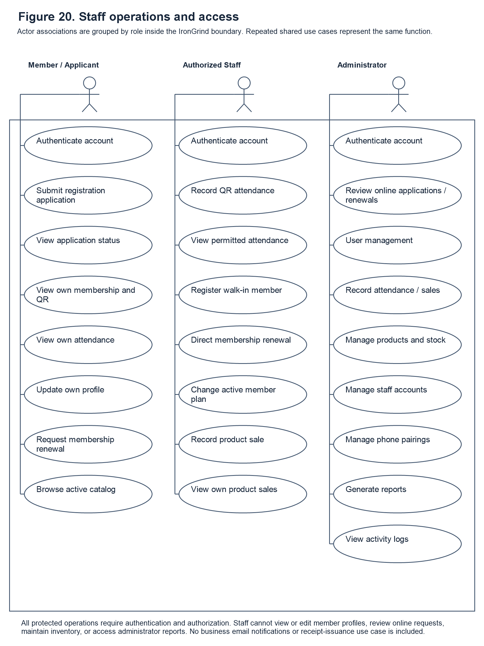

Figure 19. Member QR Code
Member QR Code The member presents this code at the gym so staff can record attendance.

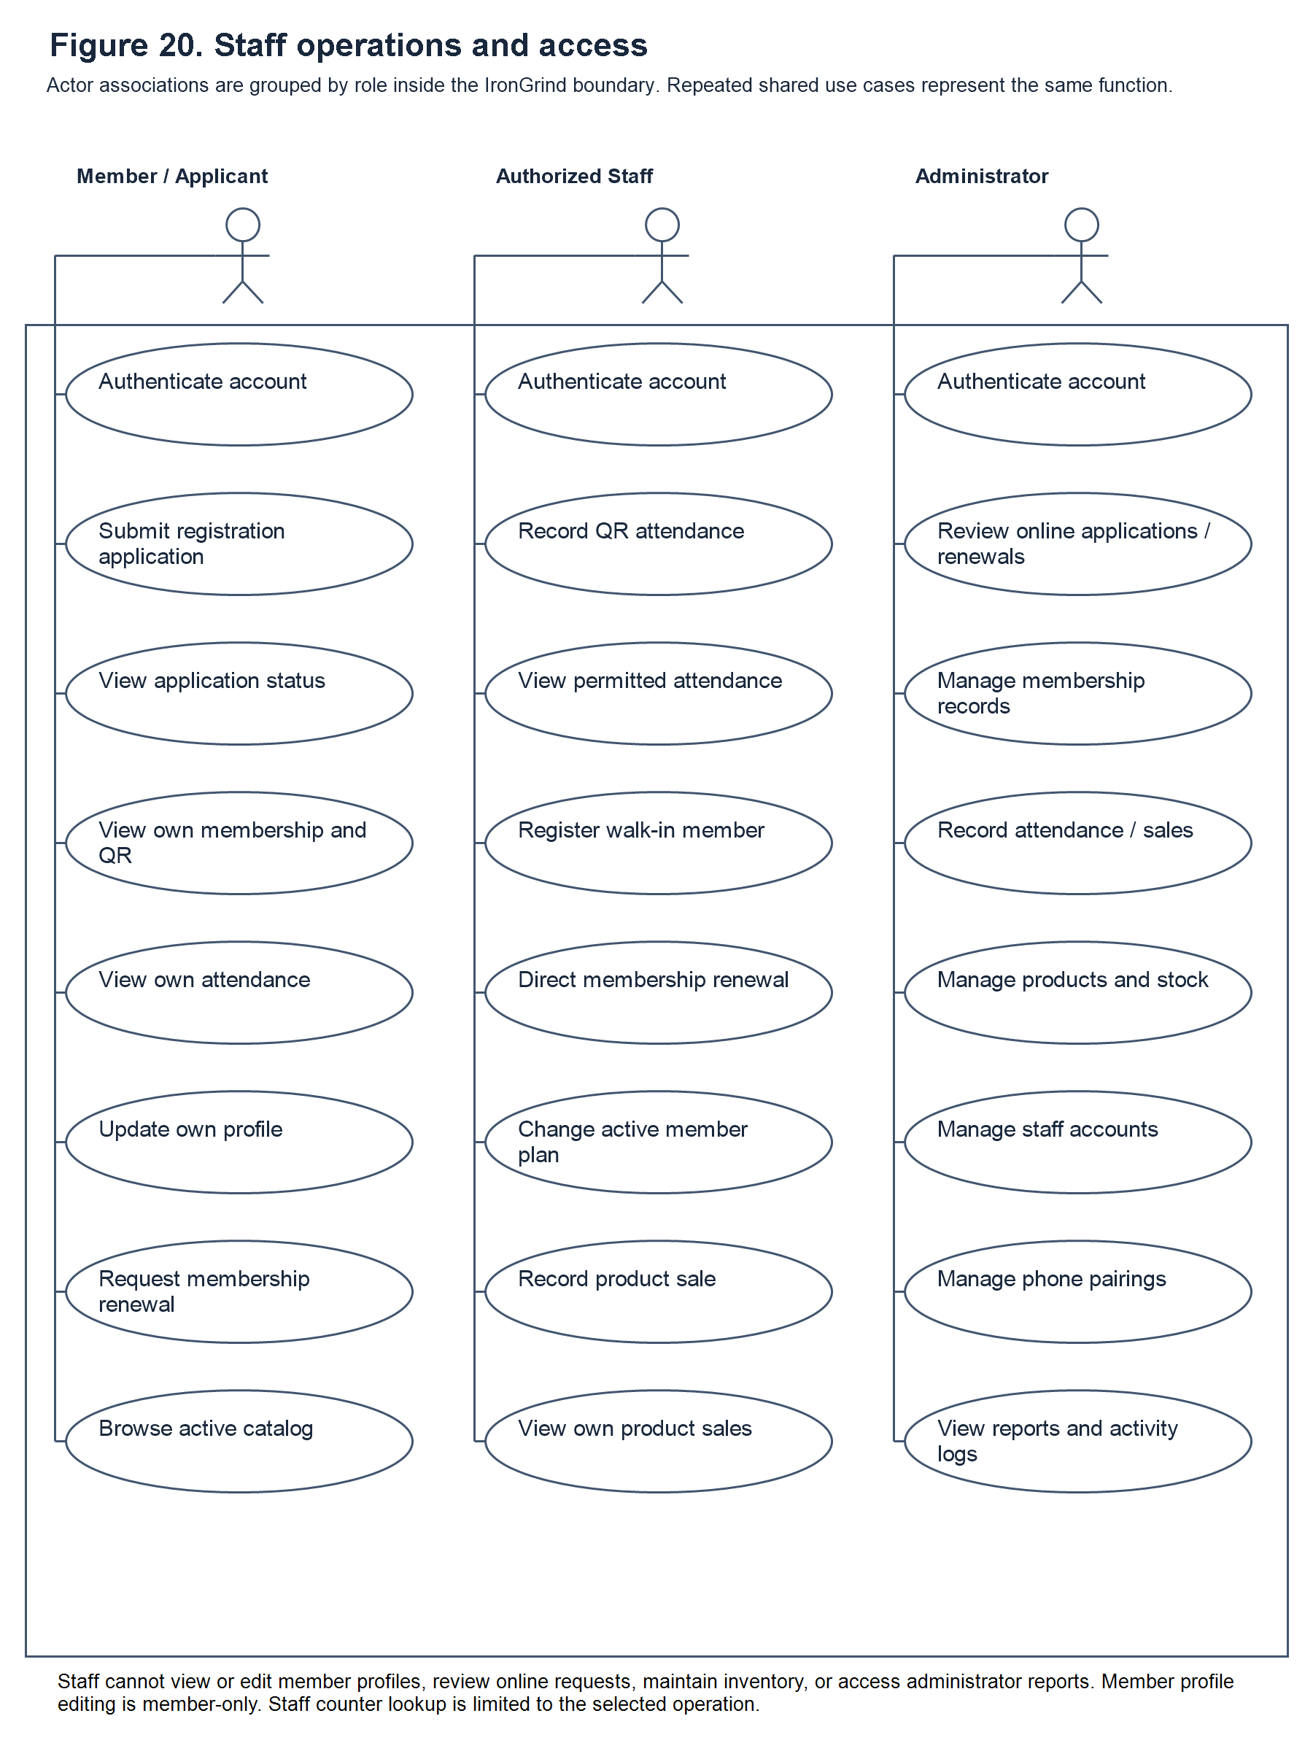

Figure 20. Staff operations and access
Staff Operations. Figure 20 summarizes staff attendance and counter functions and distinguishes administrator-only controls. It is a workflow illustration rather than a captured interface. The earlier receipt illustration has been replaced to match the stated transaction-recording scope.

Gantt Chart


Figure 21. Gantt Chart
The Gantt chart presents the planned development schedule for the Iron Grind System over ten weeks, from August 24 to October 28. The work is organized into three phases. During Planning (Weeks 1–4), the team identifies a potential client, interviews the client, gathers feedback, and confirms the system requirements and proposed features. During Design (Weeks 5–8), the team creates and refines the user-interface design and prototypes using the requirements and feedback gathered during planning. During Development (Weeks 9–10), the team begins implementing the frontend, backend, database, API, and supporting components while continuing work on the project chapters. The phases show how the project moves from understanding the gym’s needs to designing and developing the system.

